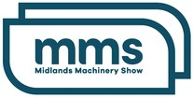
8 & 9 NOV, 2023

Exhibitor Marketing Support Guide

We’re looking forward to seeing you at the Midlands Machinery Show 2023
Our team is here to support you and ensure you get the most out of your time at this year’s show in November. We’ve put together a few ideas that will help you promote your attendance at the event and showcase to your customers why they should attend and visit your exhibitor stand.

Use the Exhibitor Pack

We’ve provided some useful resources to support your investment in exhibiting at Midlands Machinery Show 2023.

Digital marketing material:
Digital social media assets – use these to promote your attendance on your social media channels. There are multiple size options to cover the different platforms.
Web and email banners – add these to your email marketing communications as a great visual to tell people about the show.

These can all be downloaded from the exhibitor page on our website, under the ‘How we can support you’ section - https://midlandsmachineryshow.com/why-exhibit

Physical marketing material:
Roadside boards – attach to lamp posts or street signs on your property, in a demonstration vehicle or machine or anywhere outside.
Vinyl stickers – Stick them where you customer will see them!
Leaflets – Put these on a customer-facing counter, making it easy for them to pick up and are an effective way to reach many people.
A3/A4 Posters – display these behind your counter, in showroom windows or other areas of high customer footfall, these can be downloaded via our website or physical versions can be sent.

If you would like any of these physical marketing materials sent to you, please get in touch via our contact details below. But be quick, limited time to get your orders in.

Let your audience know you’ll be at #MMS2023

The show is taking place on the 8th and 9th of November 2023, and here are just a few things you can do to let your audience know that you’re exhibiting with us.
Post on your social media channels that you’ll be exhibiting. Include one of the social media graphics from the exhibitor pack above.
Don’t forget to add your stand number or location in the caption & encourage visitors to pick up a show guide on arrival to see your location.
Tag us (Midlands Machinery Show) in your content so we are notified – we'll share it to our followers and expand the number of people who see that you’ll be there.
- Twitter: @MidsMachinery
- Facebook: @MidlandsMachineryShow
- Instagram: @MidsMachineryShow
Use the event hashtags #MMS2023 to help your audience find related content.

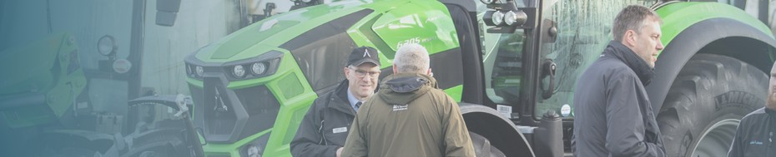
Have fun with your messaging and share with your audience what you’re looking forward to. Whether you’re showcasing a product or service, make it clear what will be at your exhibitor stand.
Share the content we’ll be posting in the run-up to the event and throughout the day.
What are you bringing to the show? If it’s a new product or service let us know, so we can shout about on social media.
Feeling brave? Try creating a video as this is more likely to show up in people’s newsfeeds.

Make the most of email
Emailing your contacts is a really great way to get your message directly into the inbox of your audience. Why not try:

Sending out an announcement that you will be exhibiting in November. Create regular countdown emails during the run-up to the Show.
Talk about the key benefits of being there, including seeing you showcase your products or services. Don’t forget to tell them to register in advance!

The show is here, now what?
Time flies and, before you know it, it will be the 8th and 9th of November. Here are a few key things you can do on the days of the Show to draw your audience to your stand and help you make the most out of your investment.
Keep an eye on your social channels and make sure you’re responding to comments and messages. Share photos of your exhibitor space and include directions of how attendees can find you.
Instagram and Facebook stories are a really useful way of documenting the day and drawing attendees to your stand.
Let us know if you would like our social media team to visit your stand, on one of the show days, to post live content.
Include the event hashtag in all content on the day, #MMS2023, we’ll be sharing live on the day.

Before you go...
Don’t forget our social channels, keep an eye on them as we approach the event. This will give you some ideas on what you can also create yourself.

Twitter: @MidsMachinery
Facebook: @MidlandsMachineryShow Instagram: @MidsMachineryShow

Make sure to tag us in your content so we can share it with our audience and use the event hashtag #MMS2023.

If you have any questions, get in touch today, you can call us on 01636 705796 or email us at info@midlandsmachineryshow.com

